**CMP6210**

**Cloud Computing 2020–2021**

Web-application report

Grocery shopping application

BSc (Hons) Computer Science

Ahmed Mohamed – 18124225

Arslan Badar – 18117505

Archibald Makotose – 18149741

Contents

Introduction 3

Aim 3

Objectives 3

Design 4

Create Accounts 5

Add Products 5

Permissions 5

AWS infrastructure diagram 6

VPC 6

EC2 11

Amazon Simple Storage Service (Amazon S3)/ S3 15

Moving to cloud 15

CloudWatch 15

Load Balancer 16

IAM 20

IAM Users IAM Groups IAM Roles 20

Tests 20

Future Improvements 21

Conclusion 22

References 23

# Introduction

This report demonstrates the implementation of a grocery shopping application deployed using cloud services (Amazon Web Services). The application allows users to register on the site and add grocery shopping items to their basket. The information needed for these items shall be stored in a MySQL database where the storage and retrieval of these items have been handled through the usage of SQL queries. The web requests and scripts have been managed using PHP, which allows for the server and database to communicate and share information. The cloud-based application makes use of several Amazon Web Service features, including – virtual private cloud (VPC), elastic compute cloud (EC2), Amazon relational database service (RDS) and more. The Amazon Simple Storage Service (S3) was used to store the images of the grocery items, by creating an S3 bucket which allowed for the storage of all the images.

Additionally, this report accompanies the design and execution of the steps taken in fully utilizing Amazon Web Administrations (AWS) online service to make an online web application which runs from it. Further accompanying the report is the documentation of the interaction of the web application assembled. Utilizing MySQL, XAMMP and PHP the shopping web application in creation was made to run locally. MySQL database on the XAMMP server was utilized to store the information entered by the client/ user and PHP permitted composed information / data to be stored by associating server and database by connection. Utilizing the AWS cloud worker services, the application was later moved from running locally . It incorporated different AWS administrations to make the application to be exceptionally accessible and secure. By executing and utilizing the distinctive cloud includes the application was upgraded further to remove errors and anomalies which were hindering the web application being developed to run efficiently. Some of the Amazon Web Services which were utilized in the development were EC2, RDS, S3, CloudFront, Elastic Load balancer, CloudWatch.

# Aim

To implement a grocery shopping application to allow users to add items to their basket.

Objectives

. To create a database containing names of items, images and prices.

. Implement a feature where users can create accounts.

. To allow users to add items to the basket.

# Design

Hypertext Pre-processor (PHP), HyperText Markup Language (HTML), Cascading Style Sheets (CSS) and Javascript are a portion of the languages that were utilized to develop and create the user interface of the web application For the styling of UI (user interface) pages CSS was significantly utilized. PHP is a HTML embedded programming language used to develop Web applications. SQL is a language used in programming and expected to control information contained in a relational database management system (RDBMS) (Beaulieu, 2009).

While running locally, the server which was utilized was XAMPP as it can download, use furthermore, contains MySQL which is a social data set administration framework which was fundamental in project improvement. To associate the data set and the interface, PHP was utilized to connect the two.

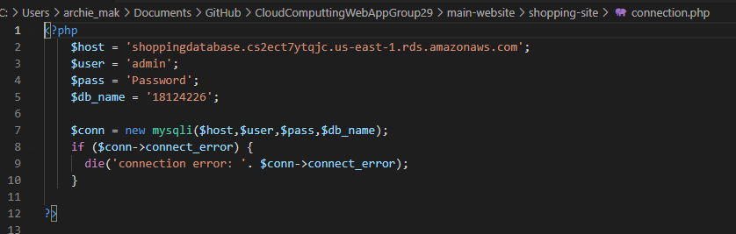

Figure above shows the connection between the website and the database RDBMS information base.

Firstly, a server will be needed on AWS. This is to allow client requests to be handled. The database shall make use of tables – a table for products and a table for users.

|  |  |  |  |  |  |  |
| --- | --- | --- | --- | --- | --- | --- |
| (Int)ID | (String)Name | (Currency)Price | (String)Image | (String)Category | (Int)Ratings ( /5) | (String)Description |
| 1 | Apple | 50p | … | Fruit&Veg | 4 | Ingredients/Allergies |
|  |  |  |  |  |  |  |
|  |  |  |  |  |  |  |
|  |  |  |  |  |  |  |

|  |  |  |  |  |
| --- | --- | --- | --- | --- |
| (Int)ID | (String)Username | (String)Password | (String)Email | (Int)Phone No. |
| 1 | Admin | Oiejt48t | Admin@ | 0121 3459699 |
|  |  |  |  |  |
|  |  |  |  |  |

## Create Accounts

Click ‘signup’ (Transitions to signup page) – Enter Username – Enter Email – Enter Password – Enter phone number - Click ‘create account’(Transitions to ‘home’ page).

## Add Products

Only the admin can add products to the database.

(Same login process as users) After logging in, transitions to admin page with admin options such as adding products – Click ‘Add Products’ – Form appears to enter product details – Click ‘submit product’.

## Permissions

|  |  |
| --- | --- |
| User | Admin |
| Can add items to cart | Can add items to cart |
| Remove items from cart | Remove items from cart |
| Sign in/out | Sign in/out |
| View products | View products |
| Option to checkout | Option to checkout |
| Update account details | Update account details |
| Contact admin/store | Add/remove users |
| Choose payment method | Add/remove products |
|  | View user details |
|  | Update product details |

# AWS infrastructure diagram

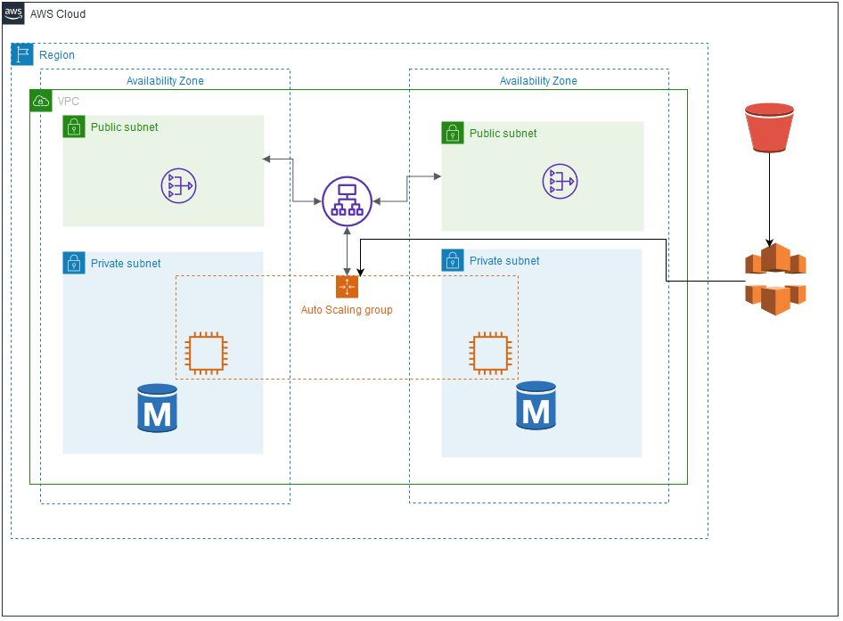

# VPC

To begin, we first need to create our Virtual Private Cloud. According to AWS (2021):

*Amazon Virtual Private Cloud (Amazon VPC) is a service that lets you launch AWS resources in a logically isolated virtual network that you define. You have complete control over your virtual networking environment, including selection of your own IP address range, creation of subnets, and configuration of route tables and network gateways.*

A VPC is devoted to an AWS account. A VPC is appointed subnets, which are a scope of IP addresses in the VPC. To move the Shopping application to the cloud, an Amazon VPC must be made: First the VPC Wizard must be dispatched

This shall be named *Shopping Website VPC* with a CIDR block of *10.0.0.0/16* as seen below.

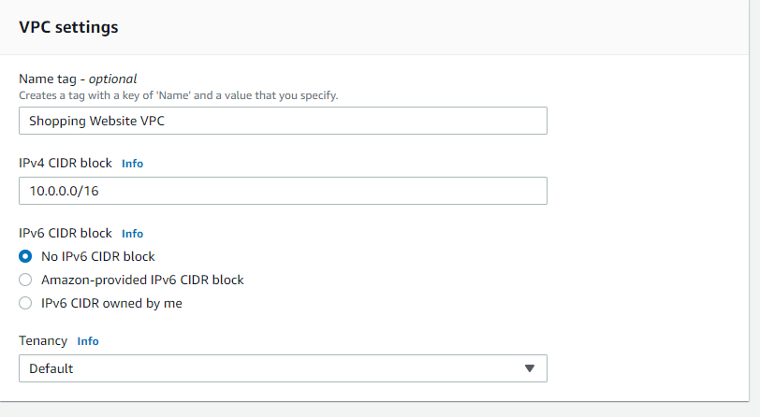

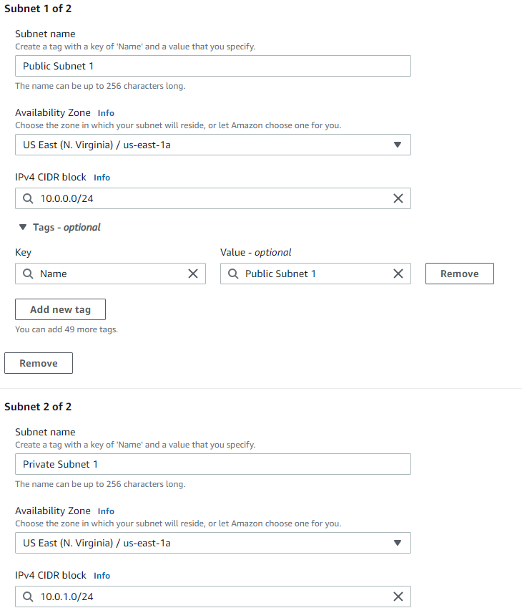A set of Public and Private subnets shall be created and assigned for two separate availability zones ‘US-East-1a’ and ‘US-East-1b’. The subnets shall be assigned a CIDR block of 10.0.**x**.0/24 (where x is a chosen digit).

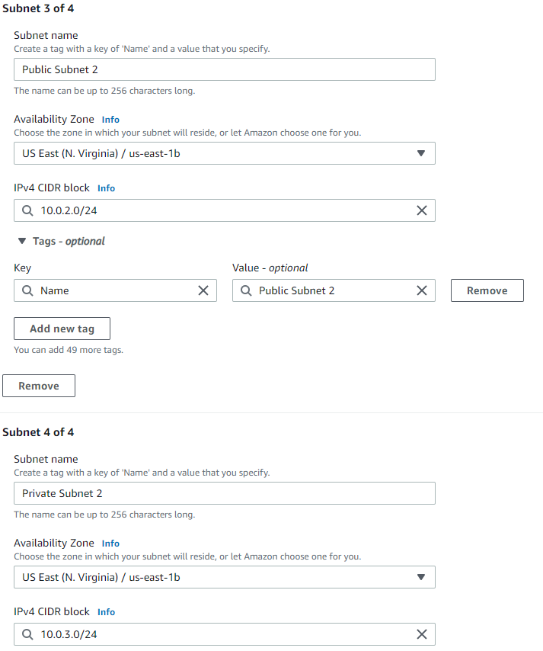

Here is a list of all the created subnets:

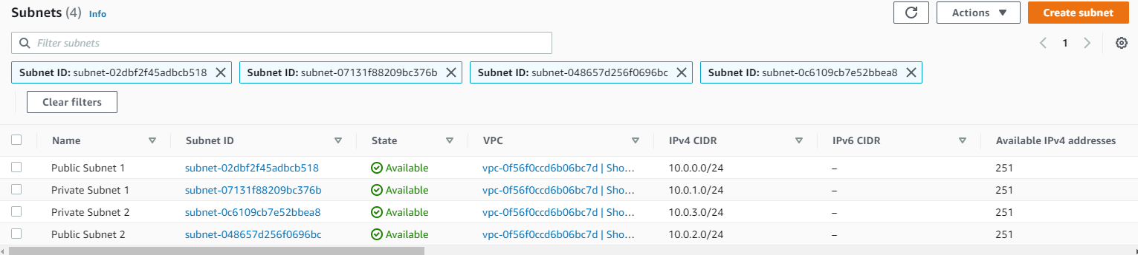

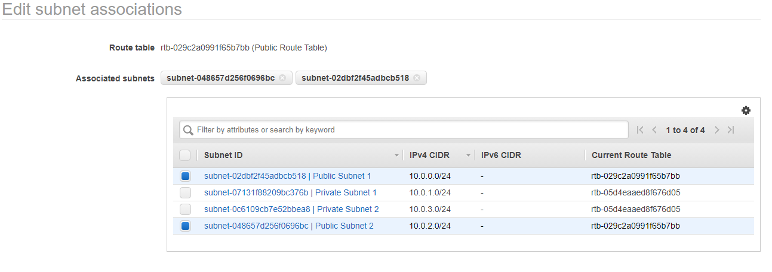Next, we’ll be editing the subnet associations for the public and private subnets. A public route table and a private route table will be created to accommodate this.

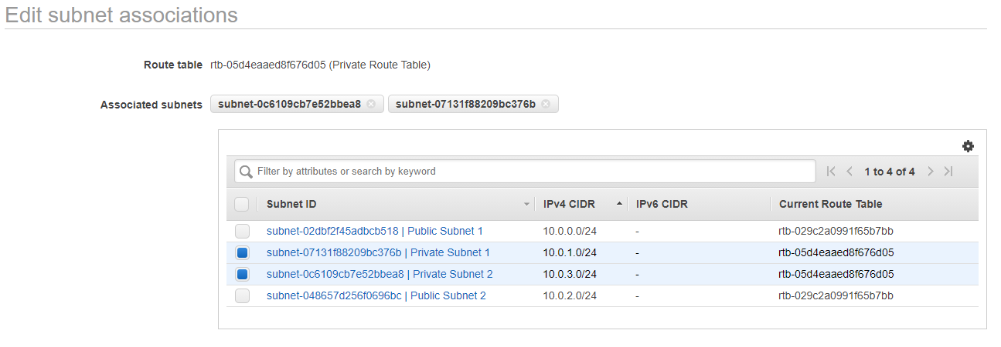

# EC2

According to Wigmore (2014), the Amazon elastic compute cloud (EC2) is a virtual server that allows for the running of applications on Amazon’s web services infrastructure. The creation of an instance will allow for unique configurations for the virtual server which the shopping website will run on.

Amazon Elastic Compute Cloud (Amazon EC2) is a web administration that gives secure, resizable process limit in the cloud (Amazon EC2, 2021). It is intended to make web-scale distributed computing simpler for programmers and developers (Amazon EC2, 2021).

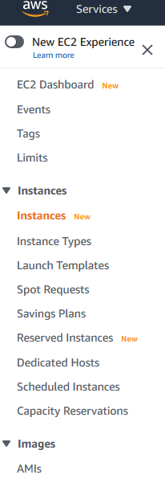

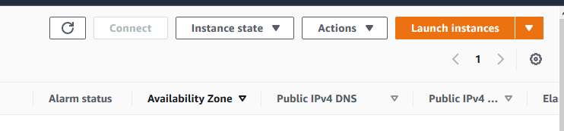

For this project, the Amazon Linux 2 AMI will be used. The instance type ‘micro’ shall be used since it is free.

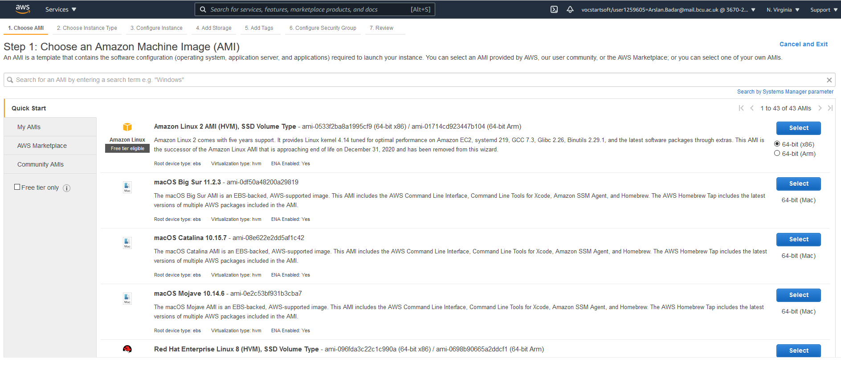

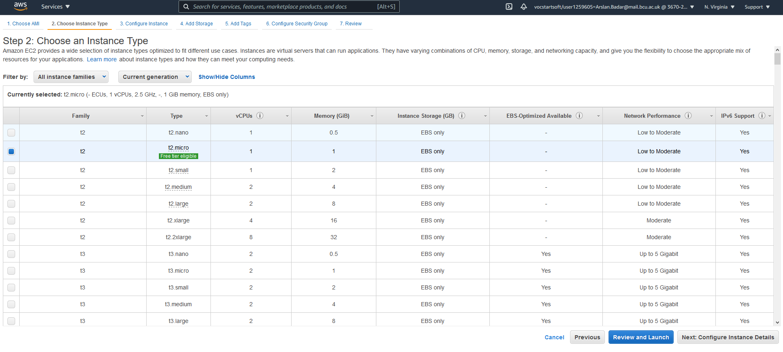

One instance shall be created, which will utilise the ‘Shopping Website VPC’ VPC previously created

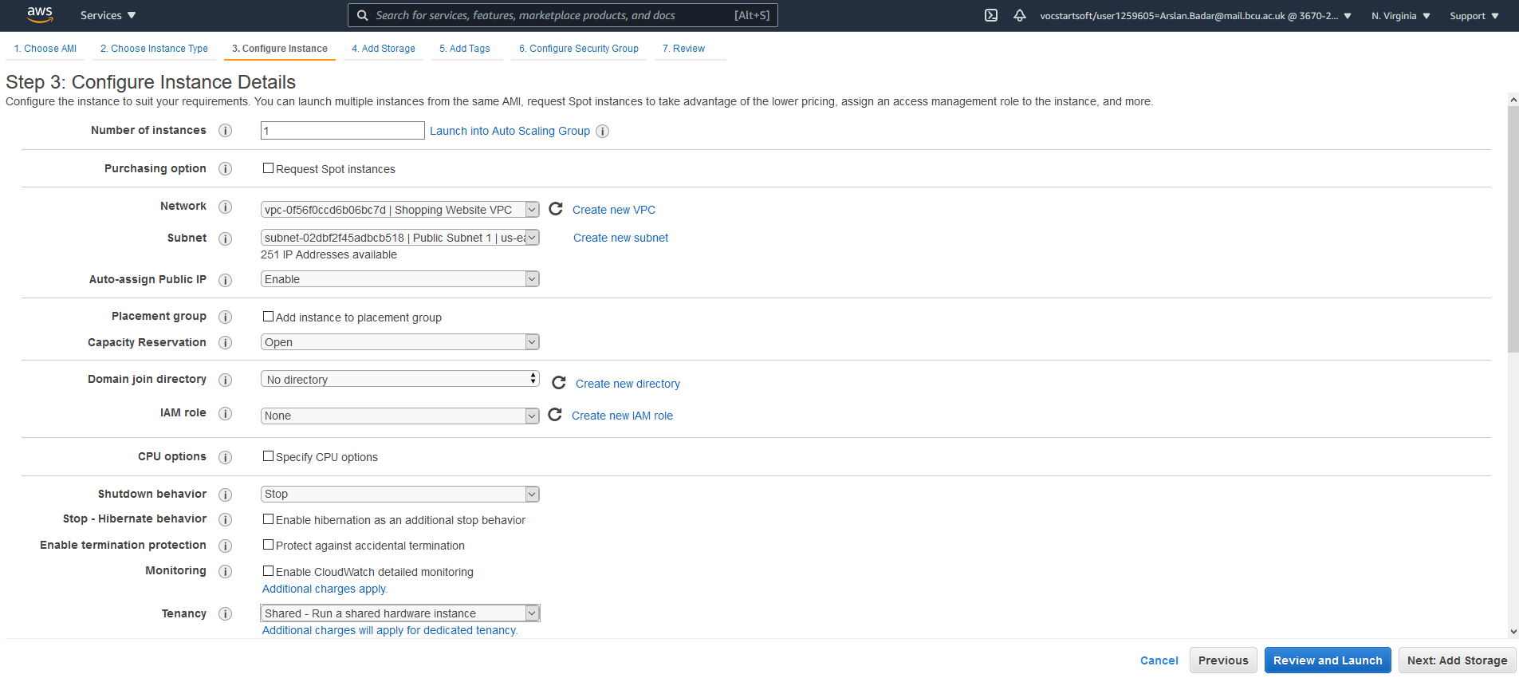

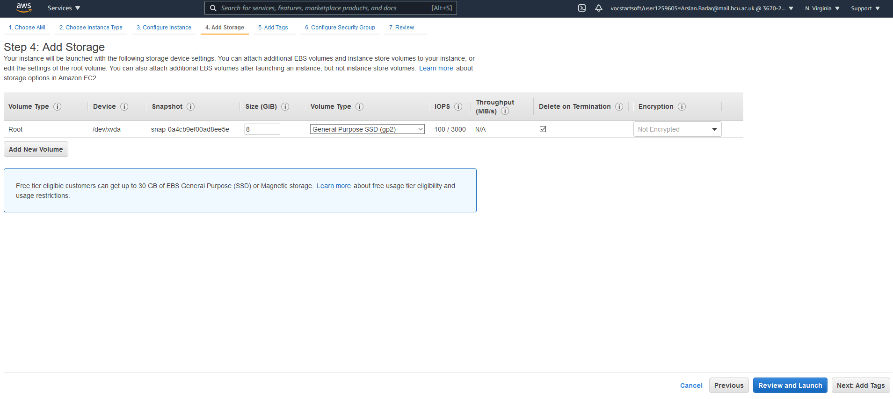

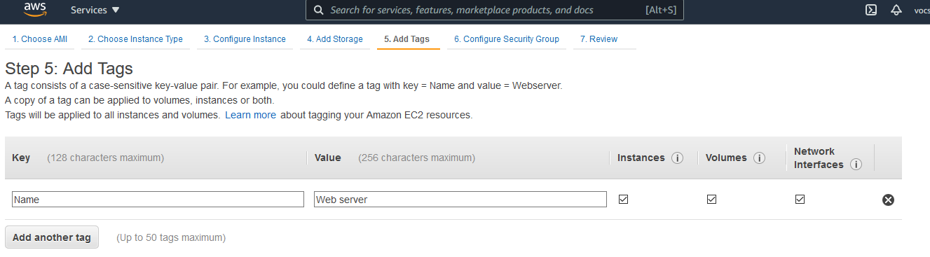

A security group for the website shall be created, titled ‘Shopping Website Security Group’. Enabling HTTP access will allow for HTTP inbound rules to be added.

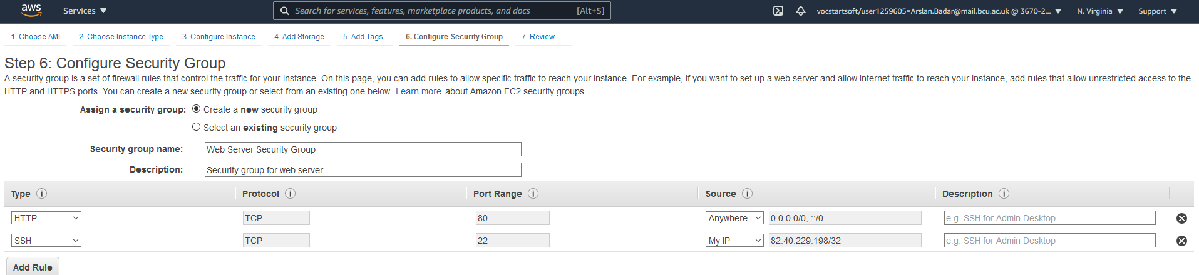

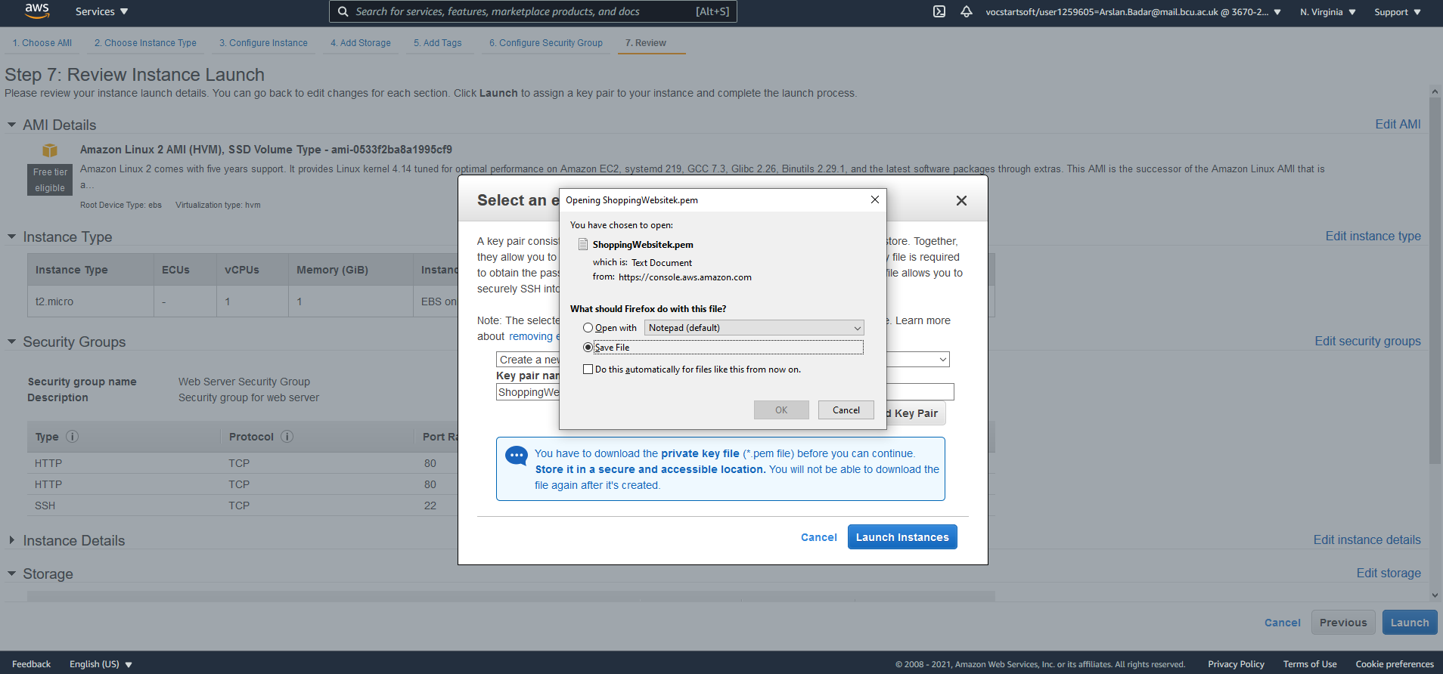

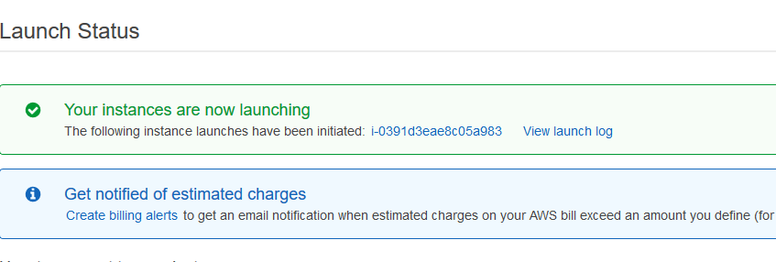

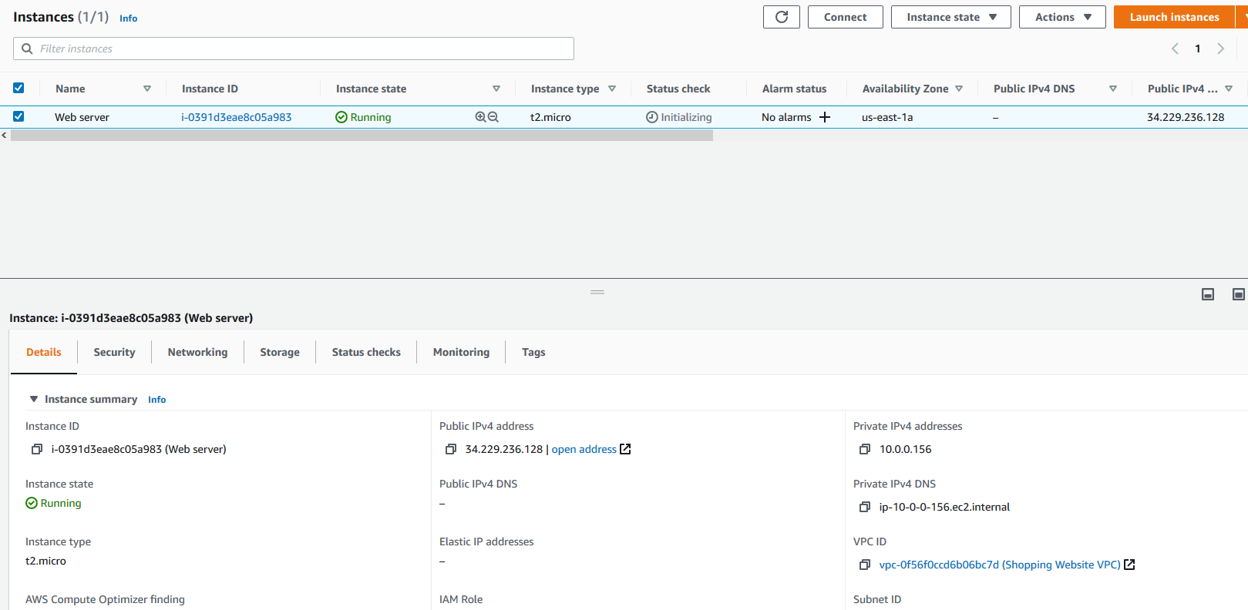

# Amazon Simple Storage Service (Amazon S3)/ S3

Amazon Simple Storage Service (Amazon S3) is an item storage service that offers industry-driving versatility, perfomance, information accessibility and security (Cloud Object Storage | Store & Retrieve Data Anywhere | Amazon Simple Storage Service (S3), 2021). Amazon S3 can be utilized to store and ensure any measure of information for a scope of utilization cases, like data lakes.

# Moving to cloud

Necessary prerequisites have been done and services have been arranged and the application was fit to be moved to the cloud. Gitbash was used ot ensurew the smoth trafnfer of application files to the cloud.

# CloudWatch

(Amazon CloudWatch - Application and Infrastructure Monitoring, 2021)

Amazon CloudWatch is a checking and recognizability service developed for designers, site reliability engineers (SREs), and IT directors among others (Amazon CloudWatch - Application and Infrastructure Monitoring, 2021). Utilization of CloudWatch gives information and noteworthy bits of knowledge to monitor your applications respond to any changes. CloudWatch gathers monitoring and operational information as logs, measurements, and occasions, provides you with a combined perspective on AWS resources and services. It can be used to identify peculiar conduct in your resourses or instances, set cautions, envision logs and measurements one next to the other, make mechanized moves, investigate issues, and find experiences to keep your applications moving along as expected (Amazon CloudWatch - Application and Infrastructure Monitoring, 2021).

Load Balancer

According to the official AWS documentation (2021):

*Elastic Load Balancing automatically distributes incoming application traffic across multiple targets, such as Amazon EC2 instances, containers, IP addresses, Lambda functions, and virtual appliances.*

This means that if there are multiple target instances and there is a sudden increase in traffic, the distribution of the load can be handled by multiple instances instead of only one. The benefit of this is that it allows more people to access the application at once and if an instance fails, there is another instance which can be used as a backup.

ELB conveys inbound organization or application trafic acrosss few selceted targets. The Load Balancer measures traffic vacillation/ wavering over a periond of time. Some of the advantages from the use of ELB are that there is exapnsion in accessiblity and simple adaptaion.process assets can be added or removed from the balancer in accordance to the changes in need or use going aong with the evolutioin of na application or product hosted without any distaburnces (Elastic Load Balancing - Amazon Web Services, 2021). The ELB futher allows the application to be exceptionally accessible.

There are different types of Load Balancers in AWS some which are Application Load Balancer which is a Layer 7 that works athe application layer and is equipped for rptuing dependantr oon parttenr design, Network Load Balancer : a layer 4 Load Balancer that tarnsport layer with the cabality of low idlenessload balancersfit for taking care of millions of requests a second and then there is the Gateway Load Balancer which is a layer 3 Load Balancer which deals with vitrtual machine traficc on the Geneve protocol (Elastic Load Balancing - Amazon Web Services, 2021).

The name of the load balancer shall be *‘LoadBalancer’*. It’ll operate on the HTTP Protocol and shall be running on port 80.

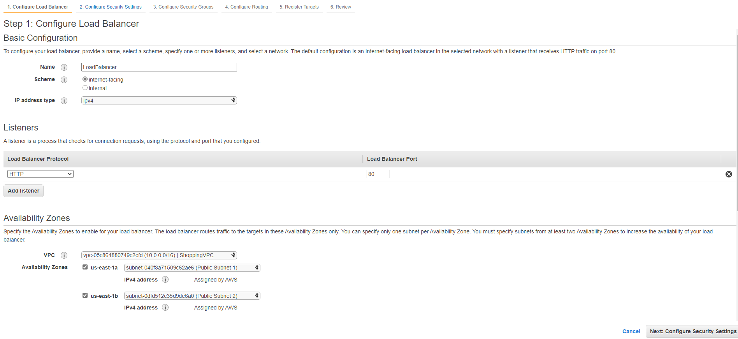

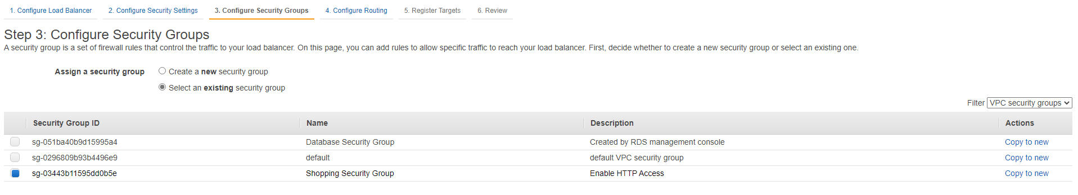

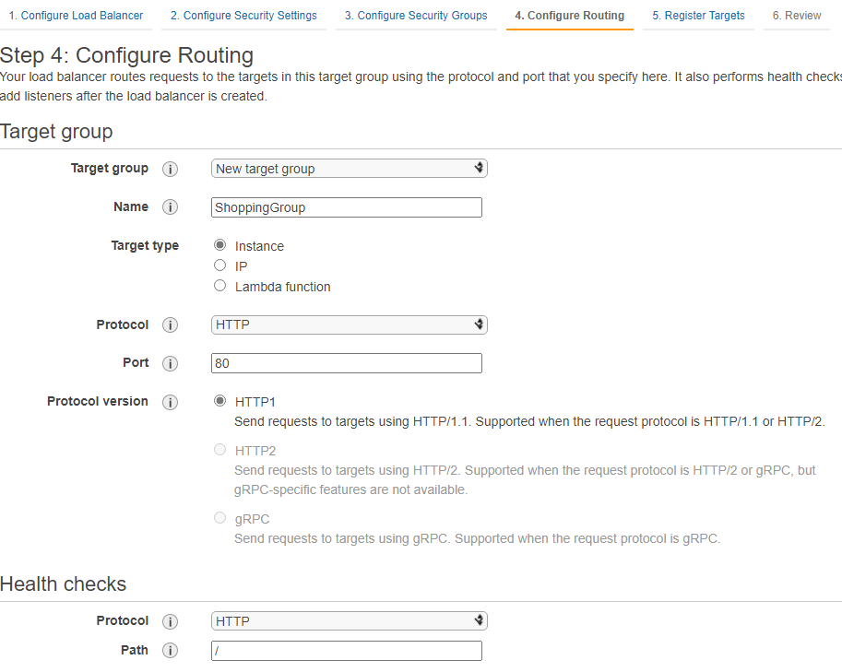

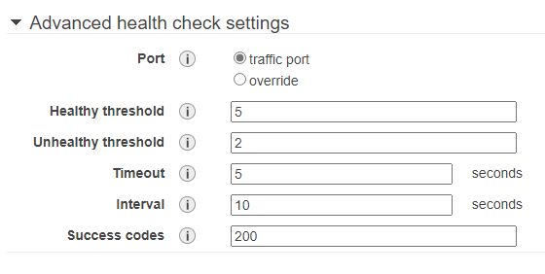

Here, both the instances have been registered as targets so that multiple instances can be used for handling the application requests.

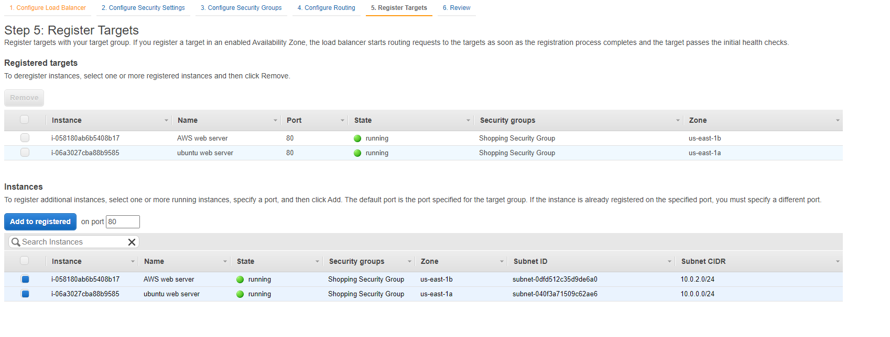

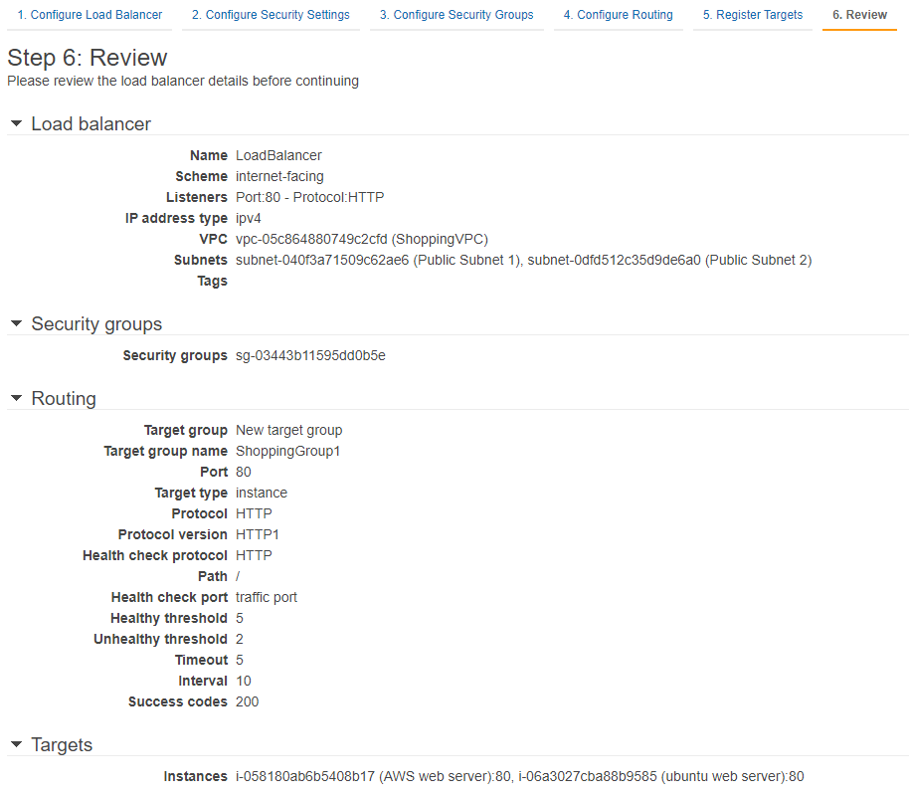

Here is the list of overall configurations for the details of the load balancer. This is to ensure that the settings are as needed, but many settings such as the allocated security group can still be changed later if necessary.

# IAM

Identity Access Management (IAM) is a feature of AWS which assists in the overseeing and the access control of AWS features and resources securely (AWS Identity & Access Management - Amazon Web Services, 2021). While utilizing IAM, it allows the creation and management of AWS users and groups and users permissions to permit or deny them access to AWS resources (AWS Identity & Access Management - Amazon Web Services, 2021).

## IAM Users IAM Groups IAM Roles

IAM Users are clients which utilize AWS features and resources. Usually this type of IAM is there to be utilized to give other individual’s authorisation to the AWS services (AWS Identity & Access Management - Amazon Web Services, 2021).

IAM Groups comprise of IAM Users / IAM clients which shows that IAM users can be grouped together as they have relative comparative arrangement (AWS Identity & Access Management - Amazon Web Services, 2021).

IAM Roles

These are tasks which have explicit consents. Likewise, you can utilize administration connected jobs to assign authorizations to AWS services that make and oversee AWS assets for your benefit.

# Tests

# Future Improvements

Several implementations could be added to the system to improve usability, competence and efficiency of the web application and in its use. An improvement which could be added in allowing users to freely manipulate / operate and customise their user profile. Adding different themes and allowing different languages to be embedded can be added to allow ease of use and to suite a user’s needs or tastes. Another improvement which can be added in the future is allowing the users or client to have the choice to be able to save their order list and have the option to reorder the same things from the saved list of past orders which would allow them to utilize less time while having the option to add or delete. In addition to the users having more control a feature to allow them to delete their account should be added to allow them ease of use and security if they feel their account has been compromised.

An increased scope and variety of items / products being sold can be considered a future improvement as variety in customers will increase as well as the flow of web application users. A future addition to make which can be considered a major development is offering delivery services and allowing a user to enter an address of where to deliver the groceries/provisions. Giving the customer the option to collect goods at will can be considered as a beneficial addition. Giving users ability to update or change their account as well as giving them the options to use different methods to pay will increase users and will be a great addition to the system.

The current shopping application being run on the AWS system services allows the user to register and login into the system. In the same system administrators run and manage the system and can be login in their own set pages dissimilar from the customers/clients. Presently, the shopping application web application has been completely incorporated into AWS cloud services further increase of use of offered service would be an improvement as it would increase efficiency, competence and ease of use. Utilization of AWS services like Elastic Beanstalk would immensely assist ands improve the management of the web application. Elastic Beanstalk is a simple easy to use AWS service which focuses on the scaling of a website through the use of Java, this would be immensely helpful to the management of the web application as the application is bound to have an increased traffic flow of customer/clients using the application services (AWS Elastic Beanstalk – Deploy Web Applications, 2021).

Utilizing AWS Elastic Beanstalk would assist by making the configuration setup of other AWS services to be completed faster and automatically (AWS Elastic Beanstalk – Deploy Web Applications, 2021). Another improvement that would be advantageous to the application is Auto Scaling, which can be viewed as vital expansion as it would essentially improve the adaptability in cloud design. Auto Scaling would naturally scale the application without the designers doing it physically (AWS Auto Scaling, 2021). Additionally, the use of AWS Lambda could be considered as it simple to use and only requires code to be added as a zip file. AWS Lambda would be beneficial as it automatically runs the loaded code and would not have physical servers to manage continuous automatic scaling as it would scale precisely with the size of workload being run (AWS Lambda – Serverless Compute - Amazon Web Services, 2021). Furthermore AWS Lambda would allow cost optimized with millisecond metering which will require payment for compute time consumed and consistent performance at any scale as it can optimise code execution time by choosing the right memory size for the function (AWS Lambda – Serverless Compute - Amazon Web Services, 2021).

# Conclusion

In conclusion taking everything accrued into account, AWS allowed the move of the web application to be moved from a local machine to the cloud. The AWS services offered more services for the completed application though some needed to be administrator activated and initialised for them to work which we could not activate ourselves. AWS provided some advantages such as providing high accessibility, adaptability and provided highlights for the services used which gave helpful statistics which were helpful for further application manipulation. Utilization of Cloud Watch proved useful as it was seen to provide logs , measurements and provided cautions to EC2 instances.

Lastly, there were few constraints which were observed as mentioned above, a portion of the services could not be fully utilized which was the downside of the AWS cloud platform which was caused by absence of consent of utilisation from the administrators of the account types which were in use by students. Though there some downsides in the development of the Shopping application a lot of promise was shown and accentuated in the services which were used and rendered by the AWS platform as they were able to host the application for a while.

# References

AWS. (2021)*Amazon Virtual Private Cloud* Available at: [Amazon Virtual Private Cloud (VPC)](https://aws.amazon.com/vpc/?vpc-blogs.sort-by=item.additionalFields.createdDate&vpc-blogs.sort-order=desc) (Accessed: 2nd April 2021)

Wigmore, I. (2014) *Amazon EC2 instance* Available at: [What is Amazon EC2 instance? - Definition from WhatIs.com (techtarget.com)](https://searchaws.techtarget.com/definition/Amazon-EC2-instances#:~:text=An%20EC2%20instance%20is%20a,programs%20in%20the%20computing%20environment.) (Accessed: 5th April 2021)

AWS. (2021)*What is Amazon EC2?* Available at: [What is Amazon EC2? - Amazon Elastic Compute Cloud](https://docs.aws.amazon.com/AWSEC2/latest/UserGuide/concepts.html) (Accessed: 5th April 2021)

AWS. (2021)*Elastic Load Balancing?* Available at: [Elastic Load Balancing - Amazon Web Services](https://aws.amazon.com/elasticloadbalancing/?whats-new-cards-elb.sort-by=item.additionalFields.postDateTime&whats-new-cards-elb.sort-order=desc) (Accessed: 8th April 2021)

Amazon Web Services, Inc. 2021. Amazon CloudWatch - Application and Infrastructure Monitoring. [online] Available at: <https://aws.amazon.com/cloudwatch/> [Accessed 24 May 2021].

Amazon Web Services, Inc. 2021. Amazon EC2. [online] Available at: <https://aws.amazon.com/ec2/?ec2-whats-new.sort-by=item.additionalFields.postDateTime&ec2-whats-new.sort-order=desc> [Accessed 24 May 2021].

Amazon Web Services, Inc. 2021. AWS Auto Scaling. [online] Available at: <https://aws.amazon.com/autoscaling/> [Accessed 23 May 2021].

Amazon Web Services, Inc. 2021. AWS Elastic Beanstalk – Deploy Web Applications. [online] Available at: <https://aws.amazon.com/elasticbeanstalk/> [Accessed 23 May 2021].

Amazon Web Services, Inc. 2021. AWS Identity & Access Management - Amazon Web Services. [online] Available at: <https://aws.amazon.com/iam/> [Accessed 24 May 2021].

Amazon Web Services, Inc. 2021. AWS Lambda – Serverless Compute - Amazon Web Services. [online] Available at: <https://aws.amazon.com/lambda/> [Accessed 23 May 2021].

Beaulieu, A., 2009. Learning SQL. Sebastopol: O'Reilly Media.[Accessed 23 May 2021].

Amazon Web Services, Inc. 2021. Cloud Object Storage | Store & Retrieve Data Anywhere | Amazon Simple Storage Service (S3). [online] Available at: <https://aws.amazon.com/s3/> [Accessed 24 May 2021].

Amazon Web Services, Inc. 2021. Elastic Load Balancing - Amazon Web Services. [online] Available at: <https://aws.amazon.com/elasticloadbalancing/?whats-new-cards-elb.sort-by=item.additionalFields.postDateTime&whats-new-cards-elb.sort-order=desc> [Accessed 24 May 2021].